[canva link for social template](https://www.canva.com/design/DAGdapGrwTA/ywez8yi_8n3Hi_he7tOMQg/edit)*If you require graphic design support, reach out to The Energy Coalition for assistance.*

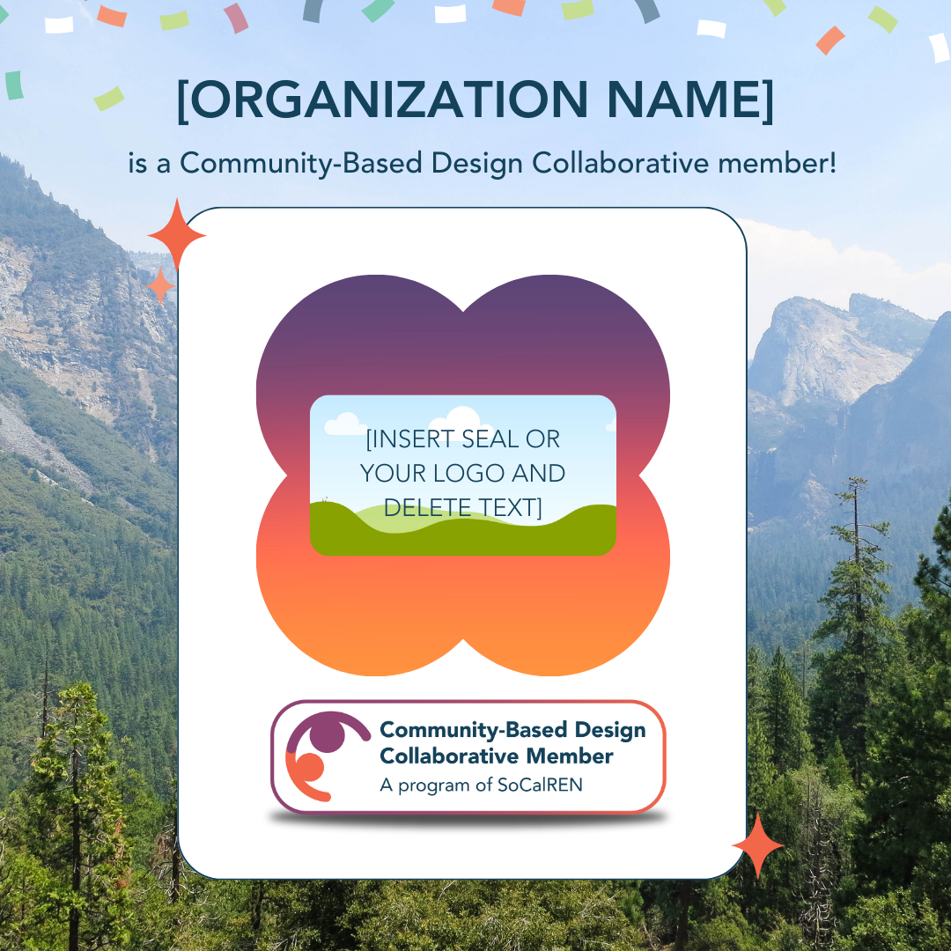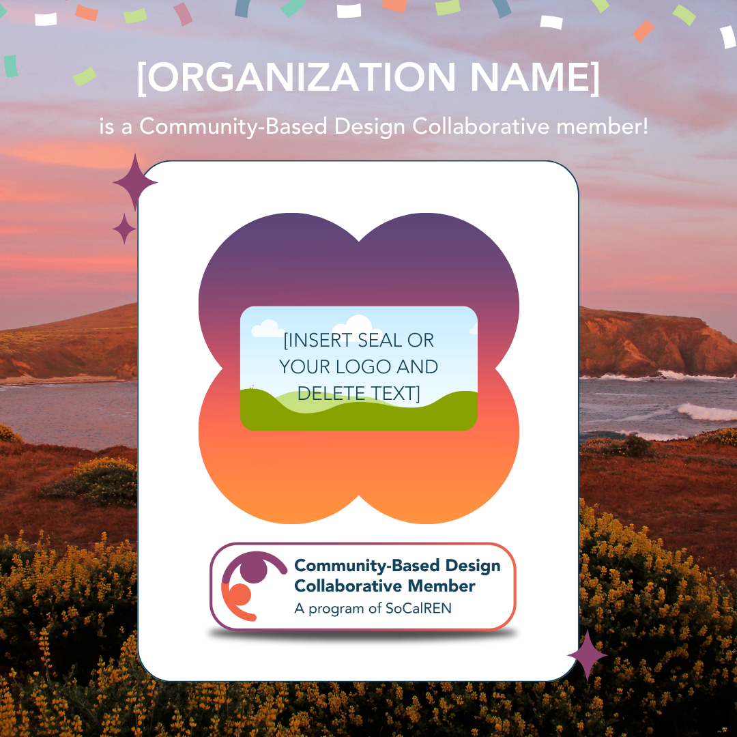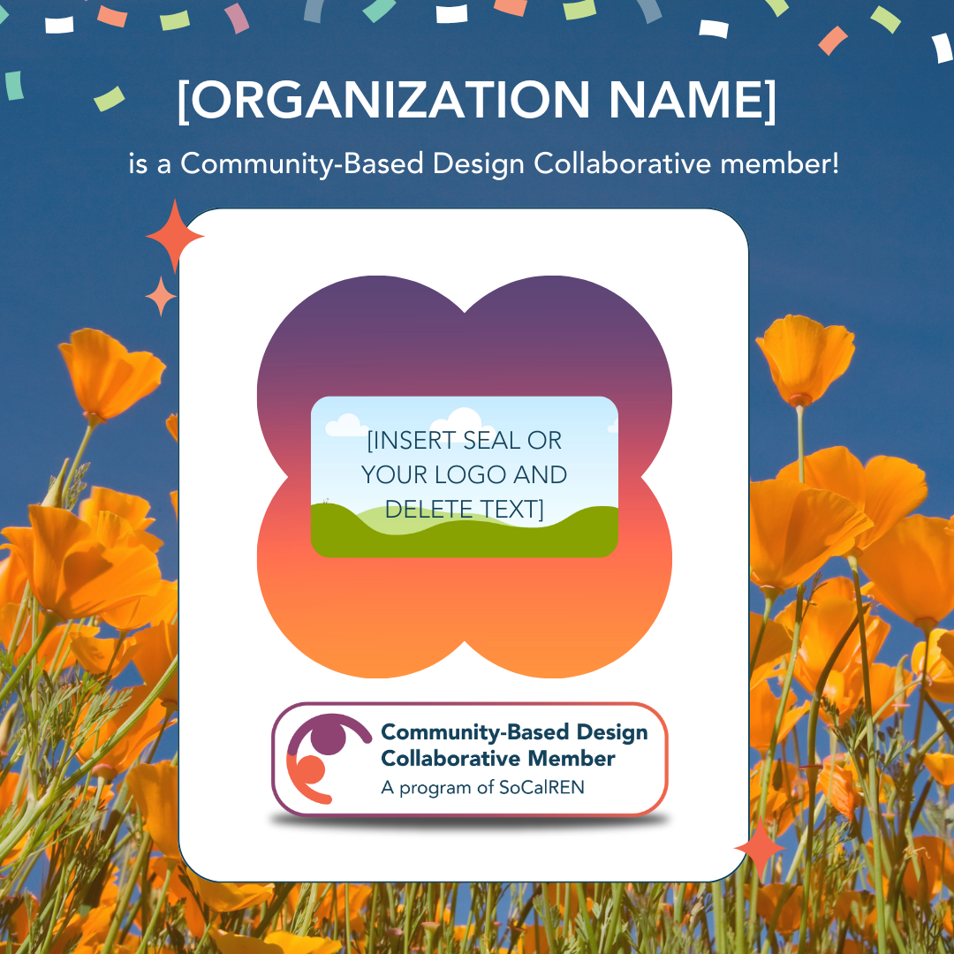

**Caption for Twitter/X**:

We're proud to be part of the Community-Based Design Collaborative (CBDC) by @_SoCalREN! We'll support the development of innovative energy programs to address local needs as communities pursue climate and energy resiliency. Learn more about CBDC at [socalren.org/about/collaborative](http://socalren.org/about/collaborative)

**Caption for Instagram/Facebook/LinkedIn**:

We are proud to be a part of the Community-Based Design Collaborative (CBDC) by @_SoCalREN. CBDC was launched to empower community involvement in energy efficiency program design and advance the CPUC’s [Environmental & Social Justice Action Plan](https://www.cpuc.ca.gov/-/media/cpuc-website/divisions/news-and-outreach/documents/news-office/key-issues/esj/esj-action-plan-v2jw.pdf).

At [INSERT ORGANIZATION NAME], we [INSERT DESCRIPTION.]

As a CBDC member, we’ll provide our expertise to help develop innovative and impactful energy programs that will address local needs as communities pursue climate and energy resiliency. Learn more about CBDC at [socalren.org/about/collaborative](http://socalren.org/about/collaborative)